Repeated Measures ANOVA
A counseling Psychologist is studying the impact of three different therapeutic techniques on client self-esteem. Five clients participated in each of the following three conditions. 1) Cognitive Behavioral Therapy (CBT), 2) Mindfulness-Based Therapy (MBT) and 3) Supportive Counseling (SC). The client receives on month of each type of therapy at the end of each month, they complete a standardized self-esteem questionnaire (0 – 30, higher scores == higher self-esteem). Client scores for each treatment are listed below:
Client | CBT | MBT | SC
1 | 24 | 22 | 18
2 | 26 | 25 | 20
3 | 21 | 19 | 16
4 | 27 | 24 | 21
5 | 25 | 23 | 19

Research question: Is there a significant difference between therapy techniques?
- Fill in the table with each group’s mean, within groups sum of squares, (SS_{W}), sum of squares between groups participants (SS_{B}), degrees of freedom
Client | CBT | MBT | SC | Client Means (M_{P}) | (M_{P} – M_{G})²
1 | 24 | 22 | 18
2 | 26 | 25 | 20
3 | 21 | 19 | 16
4 | 27 | 24 | 21
5 | 25 | 23 | 19
Condition Means |  |  |  | M_{G} = ________ | SS_{B} = _____ × k  SS_{B} = ______
SS (within treatments)
df (Within Treatments)
 |  |  |  | SS_{w}
 |  |  |  | df_{w}
 |  |  |  | df_{R}
 |  |  |  | df_{T}
 |  |  |  | df_{B}

- Calculate Sum of Squares Total (SS_{T}) (hint: Draw a table)

- Using the values from problems 1 and 2, calculate SS_{M} and SS_{R}

- Calculate MS_{R} and MS_{M}

- Compute F

- Based on this test, is there a significant difference between study groups? Why or why not? (Use the F table)

Formulas
SS Formulas

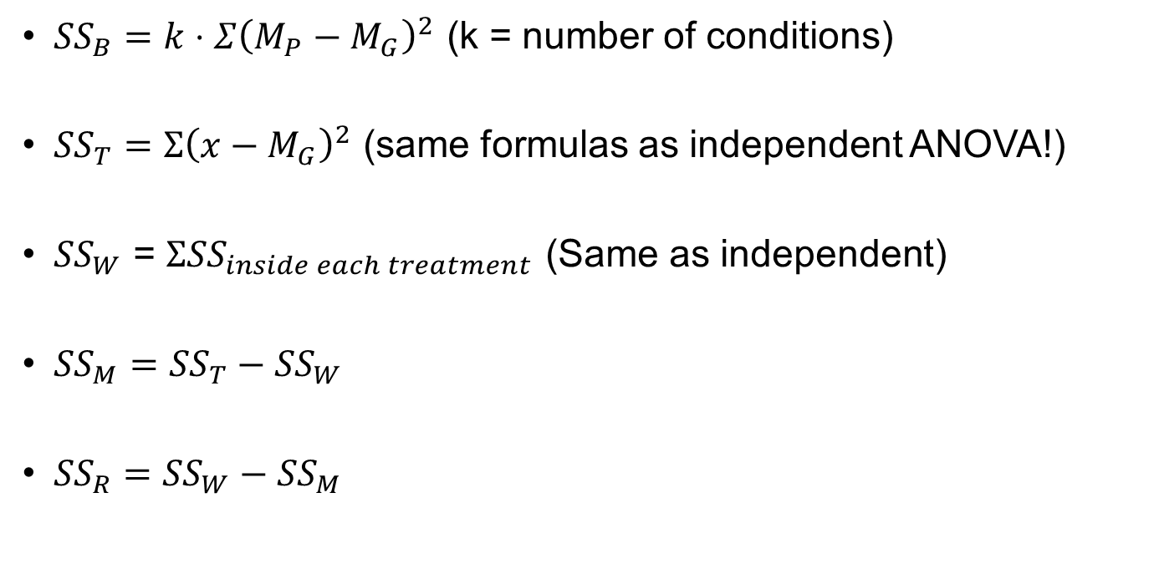
MS Formulas
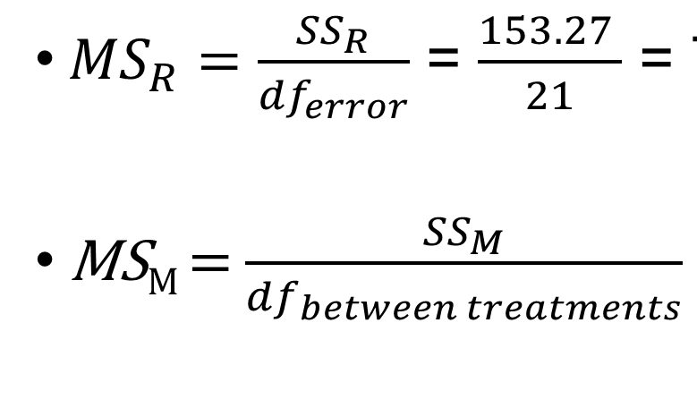
F Formula
- MS_{M} / MS_{R}

df Formulas
- ${df}_{error}={df}_{within}-{df}_{between subjects}$
- ${df}_{between subjects}=n-1$
- ${df}_{treatments}$ = k – 1
- df_{within} = df within each treatment, added together

